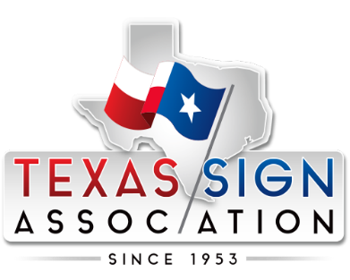

Texas Sign Association Code of Ethics
As a member of the Texas Sign Association, I recognize that my actions, business practices, and professional conduct reflect not only on myself, my employees, business partners, and customers, but also on the Association and the sign industry as a whole.
I am committed to conducting my business with integrity, professionalism, and respect. My goal is to uphold the highest ethical standards and contribute to advancing the sign industry, leaving it stronger than I found it.
As a member of the Texas Sign Association, I pledge to:
- Honor my profession by recognizing the value of my work and the positive impact it has on the businesses and communities I serve.
- Conduct business ethically and fairly, understanding that honesty, integrity, and fair competition are the foundation of long-term success and mutual prosperity.
- Deliver quality and excellence by producing signs and related products that meet the highest standards of craftsmanship, fulfill customer expectations, and comply with all applicable laws, codes, and community requirements.
- Promote fair competition by competing through innovation, quality, service, and continuous improvement rather than by disparaging competitors or engaging in unfair business practices. When possible, I will strive to exceed expectations.
- Serve my community responsibly by acting with professionalism, respect, and accountability, recognizing my responsibility to contribute positively to the communities in which I live and work.
- Support the Texas Sign Association by actively participating in its mission to promote, protect, and strengthen the sign industry throughout Texas. I understand that the Association’s success depends upon the commitment, cooperation, and mutual respect of its members working together for the benefit of the industry.
Through these principles, I affirm my commitment to ethical business practices, professional excellence, and the continued advancement of the sign industry.

